SQL Joins

**SQL Joins**

Joins allow you to combine rows from two or more tables based on related columns.

**Why are use SQL Joins**

* Joins are used when one needs to combine data from various table.
* We normalize big table to from smaller tables to avoid various anamolies.

**Types of SQL Joins**

* **INNER JOIN**  Inner join returns all rows where there is a match in both tables.
* **LEFT JOIN** Left join returns all rows from the left table and the matched rows from the right table.
* **RIGHT JOIN** Right join returns all rows from the right table and the matched rows from the left table.
* **FULL OUTER JOIN** Full outer join returns all rows where there is a match in one of the tables.

**A good way to remember this is to think about a Venn diagram:**

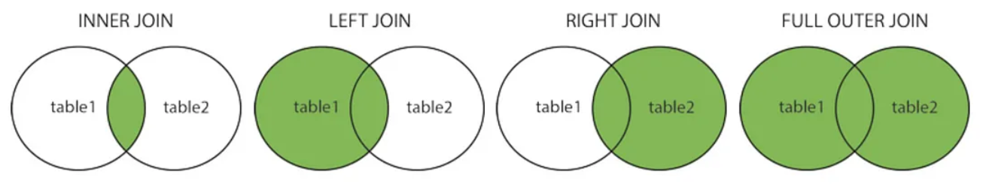

**Syntax of Inner Join :**

SELECT column1, column2 FROM table1 INNER JOIN table2 ON table1.column = table2.column;

**Query**

SELECT ID, Name, Salary, Status FROM EmpDetails INNER JOIN MaritalStatus ON EmpDetails.ID = MaritalStatus.ID;

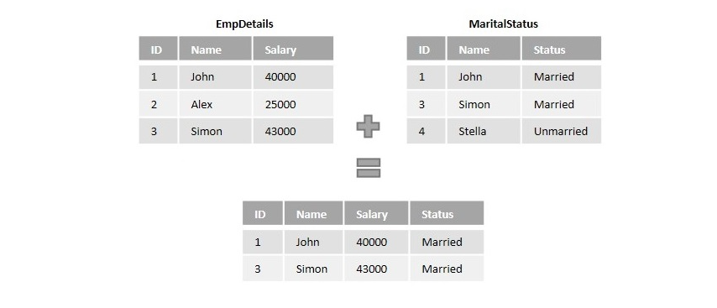

**Syntax of Left Join :**

SELECT column1, column2 FROM table1 LEFT JOIN table2 ON table1.column = table2.column;

**Query**

SELECT ID, Name, Salary, Status FROM EmpDetails LEFT JOIN MaritalStatus ON EmpDetails.ID = MaritalStatus.ID;

**Syntax of Right Join :**

SELECT column1, column2 FROM table1 RIGHT JOIN table2 ON table1.column = table2.column;

**Query**

SELECT ID, Name, Salary, Status FROM EmpDetails RIGHT JOIN MaritalStatus ON EmpDetails.ID = MaritalStatus.ID

**Syntax of Full Outer Join :**

SELECT column1, column2 FROM table1 FULL JOIN table2 ON table1.column = table2.column;

**Query**

SELECT ID, Name, Salary, Status FROM EmpDetails FULL JOIN MaritalStatus ON EmpDetails.ID = MaritalStatus.ID

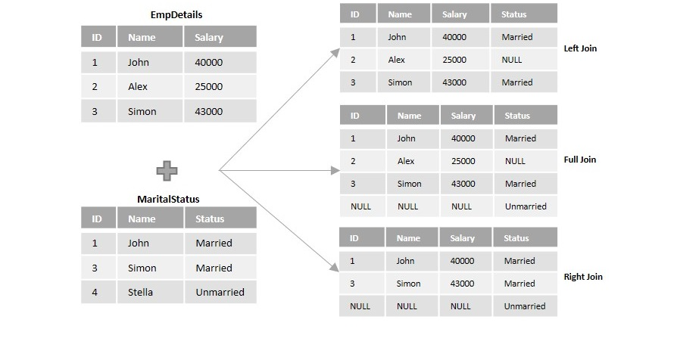

**Note:** Foreign key are used to do reference to other table.